**6. Testing**

Several test mechanisms were applied to the prototype to verify that it has met the functional requirements and the design constraints mentioned in section 3. This section also proves how our prototype provides the solution to the problem stated in section 1.

The testing follows two main parts: First part is the black box testing which tests the system functionalities without inspecting the detailed internal processes and is applied through several stages. Second part is the outdoor testing where ultrasonic sensor was tested outdoor.

Part A: Black box Testing

1. Unit Testing

*Tests:* Individual subsystems

1. Integration Testing

*Tests:* Interface between groups of subsystem or external systems

1. System Testing

*Tests:* Entire system

* 1. Functional Testing

*Tests:* Functional requirements

* 1. Quality Testing

*Tests:* Non-functional requirements

* 1. Acceptance Testing

*Tests:* Customer requirements

Part B: Outdoor Testing

***Part A: Black Box Testing***

6.1. Unit Testing

Tests the system components/subsystems individually to confirm that the component functions correctly and that the subsystem is coded correctly and performs the required functionality.

6.1.1. Hardware

Components

**Ultrasonic Sensor**

Goal: Test if the sensor measures the distance of an object correctly.

Expected results: Object’s distance (maybe with a meter)

Actual results: screenshot of sensor with serial output

**RFID Reader and Tags**

Goal: Test if RFID reader reads the UID of a tag correctly.

Expected results: Tag ID

Actual results: screenshot of rfid reader with serial output

Software Implementation of the Hardware

*Reservation Free Parking Module*

1. Arduino: Detect change in ultrasonic status

Expected:

Actual:

1. Arduino & NodeMCU: Send status from Arduino to NodeMCU serially
2. NodeMCU: Update status in Firebase

*Reserved Parking Module*

1. Arduino: Get scanned UID tag from RFID Reader (Same as RFID Reader and Tags component test)
2. Arduino & NodeMCU: Send UID from Arduino to NodeMCU serially
3. NodeMCU & Arduino: Check if there is a valid reservation with the UID tag received from Firebase. Change reservation status and Arduino opens gate (Green LED)

6.1.2. Software

a. Application

b. Website

6.2. Integration Testing

Tests a group of subsystems and eventually the whole system to ensure that they are *interfaced* correctly.

**6.2.1. System Integration**

**6.2.2. Firebase Connectivity Testing**

The connectivity test measures the average time it takes for a connection to pass data between a certain component in the system and Firebase. This test shows to what extent our system is real time and its speed. All tests were done in the same environment, internet connection and around the same time. In the application and NodeMCU, the time was recorded by the following algorithm:

* Step 1: read system time and store it in a variable called startTime
* Step 2: Preform needed operation with Firebase
* Step 3: read system time again and store it in variable called endTime
* Step 4: subtract the startTime from endTime and display result in the console

**In contrast, the website uses a different algorithm to record the time:**

Using Postman as a testing tool, by firstly creating new routes for reading/writing without displaying pages content and applying GET/POST requests using Postman as it automatically calculates the time it took for the response to arrive.

Four trials were computed for each connection, and then the average test time was calculated.

The test is done through several levels:

* Between NodeMCU and Firebase
* Between Application and Firebase
* Between Website and Firebase

6.2.1. Between NodeMCU and Firebase

The internet connection between NodeMCU and Firebase was tested by measuring the time NodeMCU needed to read from or write to the Firebase database. The system requires NodeMCU to deal with two main operations when communicating with the Firebase. First operation is to get all reservations in the database and second operation is to get or update (set) a specific value in a node. Both operations have different data sizes and thus the time taken for each operation differs. Table 6.x shows the final results, and the detailed test is provided in the appendix.

|  |  |  |
| --- | --- | --- |
| NodeMCU *Average C*onnection Time to | |  |
|  | **Get** | **Set** |
| Reservation (177 bytes) | 0.353489 s | - |
| Update a value (15 bytes) | 0.301054 s | 0.388572 s |

6.2.2. Between Application and Firebase

The internet connection between Application and Firebase was tested by measuring the time Application needs to read from or write to the Firebase database for several data sizes. Table 6.x shows the final results, and the detailed test is provided in the appendix.

|  |  |  |
| --- | --- | --- |
| *Application Average Connection Time to* | | |
|  | **Post** | **Get** |
| Reservation (177 bytes) | 0.012112 s | 0.007586 s |
| Currently Looking (52 bytes) | 0.011627 s | 0.007296 s |
| User (113 bytes) | 0.011777 s | 0.007429 s |
| Zone (8606 bytes) | 0.017236 s | 0.008666 s |
| Spot (49 bytes) | 0.011526 s | 0.007123 s |

In general, we observe that reading (get) data from Firebase database is much faster than posting data in the Firebase regardless of the data size. The results are to our advantage since our system is real time, we care more about fetching updated data from the Firebase and reflecting it to the UI as quick as possible than we care for sending data to the Firebase.

6.2.4. Between Website and Firebase

To test internet connection to and from Application and Firebase in several data sizes

|  |  |  |
| --- | --- | --- |
| *Website Average Connection Time to* | | |
|  | **Post** | **Get** |
| Reservation (177 bytes) | 0.4838 s | 0.4242 s |
| Currently Looking (52 bytes) | 0.3824 s | 0.3690 s |
| User (113 bytes) | 0.4512 s | 0.4048 s |
| Zone (8606 bytes) | 0.8122 s | 0.8303 s |
| Spot (49 bytes) | 0.3306 s | 0.3298 s |



In average, the total time needed to read/write to and from Firebase is considered a small number, which is good for our system as it is in real time. However, the website needed more time to fetch data compared to the application. And significantly, we can find that time is directly proportional to the number of bytes. This delay in response time may refer to some factors, one of them is the server location. As it is known that server location has an impact on response time and page loading if it is far from the user location as in our case.

By using **www.iplocation.net**, we found that the server location based on its IP is located in United States. (see figure XX)

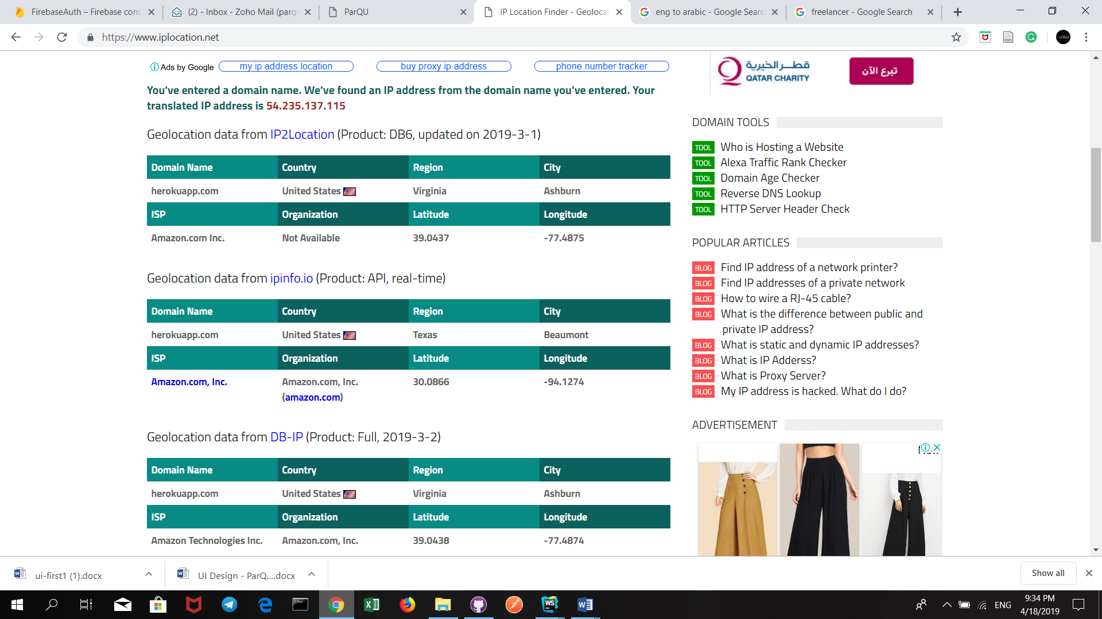

6.3. System Testing

Tests the entire system to confirm that it has met functional, non-functional and customers requirements.

**6.3.1. Functional Testing**

To test if the functional requirements of each use case specified in the use case diagram (section 3) has been met.

* Sign-up:

|  |  |  |
| --- | --- | --- |
| **Test Case ID** | **Description** | **Screenshots** |
| Sign-up 01 | VIP user creates an account successfully. |  |
| Sign-up 02 | VIP user uses an already existing email. |  |
| Sign-up 03 | VIP user leaves required fields empty |  |

* Sign-in:

|  |  |  |
| --- | --- | --- |
| **Test Case ID** | **Description** | **Screenshots** |
| Sign-in 01 | VIP user signs in successfully. |  |
| Sign-in 02 | VIP user uses a wrong email address and/or password. |  |

* Reserve Parking:

|  |  |  |
| --- | --- | --- |
| **Test Case ID** | **Description** | **Screenshots** |
| Reserve Parking 01 | VIP user reserves a parking spot successfully. |  |
| Reserve Parking 02 | VIP user already has a reservation at the selected time he/she wants to reserve on. |  |
| Reserve Parking 03 | VIP user tries to reserve at a time where there is no available parking spot. |  |
| Reserve Parking 04 | VIP user tries to reserve before the allowable reservation time which is same day or one day before. |  |
| Reserve Parking 05 | VIP user tries to reserve at a time that has elapsed. |  |
| Reserve Parking 06 | VIP user tries to reserve more than the number of allowable reservation hours per day (6 hours) |  |
| Reserve Parking 07 | VIP user is notified 30 minutes before reservation expiring time. |  |

* View Reservation:

|  |  |  |
| --- | --- | --- |
| **Test Case ID** | **Description** | **Screenshots** |
| View Reservation 01 | VIP user successfully views all his/her current and upcoming reservations. |  |

* Extend Reservation:

|  |  |  |
| --- | --- | --- |
| **Test Case ID** | **Description** | **Screenshots** |
| Extend Reservation 01 | VIP user successfully extends a reservation and the extension price is added to the reservation. |  |
| Extend Reservation 02 | VIP user tries to extend before the last hour of the reservation. |  |
| Extend Reservation 03 | VIP user tries to extend where there is no available parking spot after the reservation time. |  |

* Cancel Reservation:

|  |  |  |
| --- | --- | --- |
| **Test Case ID** | **Description** | **Screenshots** |
| Cancel Reservation 01 | VIP user successfully cancels the whole reservation and the deduction amount is calculated and deducted from the total price of the reservation, if the reservation *has not* started. |  |
| Cancel Reservation 02 | VIP user successfully cancels remaining reservation hours from now and the deduction amount is calculated and deducted from the total price of the reservation, If the reservation *has* started |  |

* View Parking:

|  |  |  |
| --- | --- | --- |
| **Test Case ID** | **Description** | **Screenshots** |
| View Parking 01 | User successfully views a map of the parking spots current status. |  |
| View Parking 02 | User successfully gets directions for a specific spot. |  |

* Request Car Care:

|  |  |  |
| --- | --- | --- |
| **Test Case ID** | **Description** | **Screenshots** |
| Request Car Care 01 | VIP user is successfully redirected to the Servesni application or website, if the application is installed on the phone |  |
| Request Car Care 02 | VIP user is redirected to the Play store, if the application is not installed on the phone |  |

* View Current Occupancy Trend:

|  |  |  |
| --- | --- | --- |
| **Test Case ID** | **Description** | **Screenshots** |
| View Current Occupancy Trend 01 | User successfully views statistical data that represents occupied percentage in each hour for selected zone for last four weeks. |  |

* Check In

|  |  |  |
| --- | --- | --- |
| **Test Case ID** | **Description** | **Screenshots** |
| Check In 01 | VIP user successfully checks in to zone if he has reservation at the current time and zone. |  |
| Check In 02 | VIP user tries to check in to zone when he does not have a reservation at the current time. |  |
| Check In 03 | VIP user tries to check in to zone when his reservation is in another zone |  |
| Check In 04 | VIP user tries to check in to zone when he cancels his reservation. |  |

* Check Out

|  |  |  |
| --- | --- | --- |
| **Test Case ID** | **Description** | **Screenshots** |
| Check Out 01 | VIP user successfully checks out of zone *when/before* his reservation time has ended (without penalty) |  |
| Check Out 02 | VIP user checks out of zone *after* his reservation time has ended (with penalty) |  |
| Check Out 03 | VIP user cancels part of his reservation using application/website and checks out of zone *when/before* his reservation has ended (without penalty) |  |
| Check Out 04 | VIP user cancels part of his reservation using application/website and checks out of zone *after* his reservation has ended (with penalty) |  |
| Check Out 05 | VIP user checks out of zone *when/before* his extension time has ended (without penalty) |  |
| Check Out 06 | VIP user checks out of zone *after* his extension time has ended (with penalty) |  |
| Check Out 07 | VIP user checks out of zone and automatic cancellation is applied when his reservation time has an hour or more left. |  |

* Update Parking Availability

s

|  |  |  |
| --- | --- | --- |
| **Test Case ID** | **Description** | **Screenshots** |
| Update Parking Availability 01 | User successfully enters/leaves a parking spot and the availability status of the parking spot is updated. |  |

6.3.2. Quality Testing (Design Constraints Evaluation)

To test if the non-functional requirements in section 3 has been met.

|  |  |  |  |
| --- | --- | --- | --- |
| **Name** | **Description** | **Met/Not Met** | **How the design was met?** |
| Availability | The system should always be available and real time. |  | The android application and website can be available at all times given that the devices accessing the application or website is connected to the internet. Also, for the system to work, NodeMCU must be connected to the internet.  The system is real time by using Firebase Realtime Database that allows any change in the sensors to be immediately updated in the database, which in turn automatically displays the changes in the android application and website without the need to refresh the page |
| Performance | The system should complete the required functionalities within a short response time, providing accurate readings from sensors and efficient information from Android application and website. |  | Refer to section |
| Reliability | No data loss is allowed. |  | NodeMCU, Arduino, Android and the website do not save any data locally and automatically save data in the Firebase, hence if any malfunction occurs, the data will not be lost. |
| Connectivity | NodeMCU needs to be connected to the internet to collect updated data from the sensors through the Arduino board then save it in the Firebase. In addition, the mobile application and website needs to be connected to the internet to get the data from the Firebase |  | Refer to section |
| Scalability | The system can support the addition of sensors and components as well as having more users and the cloud can be upgraded accordingly. |  | ParQU can handle more VIP users with more RFID tags. Additionally, zones can be added with more components (In our prototype, a switch button is used to illustrate the scalability of our system, as explained in section (-)). All of the previous additions require more database storage, the Firebase Realtime Database allows us to store up to 1GB for free (Free Plan). Any more storage would require us to upgrade to higher plans with a specific pricing. (reference) |
| Mobility | The system can be accessed from many different platforms. |  | Website can be accessible from any type of devices and platforms such as iOS, Android and Windows, etc. Android applications can be accessible from Android devices only whether it was a mobile or tablet. |
| Power | Power source needed for:  Motor: 3-7V  Sensor: 5V  Arduino: 7-12V |  | Arduino is supplied by a 9V battery. Sensors and Servo Motor are both supplied by Arduino |

|  |  |  |  |  |
| --- | --- | --- | --- | --- |
| Quality | Name | Description | Met/Not Met | Verification |
| Economic | Design Cost | The prototype uses high quality component with affordable prices |  | The whole prototype costed us on average 550 QR (Prototype consists of two zones, each zone has four parking spots) |
| Social | Usability | A normal user with minimal software knowledge should be able to use the mobile application and the website with ease |  | Refer to section 6.3 Acceptance testing |
| Sustainability | Maintenance | The system components should be easy to replace, remove and implement. |  | The components could easily be replaced by uploading our code to a new component. |
| Quality | Performance | The system should provide efficient information and accurate readings from the parking area. |  |  |

**6.3.3. Acceptance Testing**

(To do now: write intro to the subsection)

(To do after getting feedback from professor: do the test, write review on the results)

***Part B: Outdoor Testing***

(For Ghareisa: Check meeting 16/4 notes)

ParQU is a system that should be able to be implemented outdoor in a real parking area. As an initial test to verify that our sensors are able to withstand the harsh environments of being outdoors in Qatar University and satisfy its purpose, we tested the Ultrasonic Sensor outdoors to check the availability of a parking spot.

The sensor was placed below the parking spot. Figures 6.x and 6.x shows our test accompanied with the database showing the current status of the parking spot. Figure 6.x the parking is empty, so the database shows that the status is “available”, while Figure 6.x has a car so the database shows that the current status is “not available”.

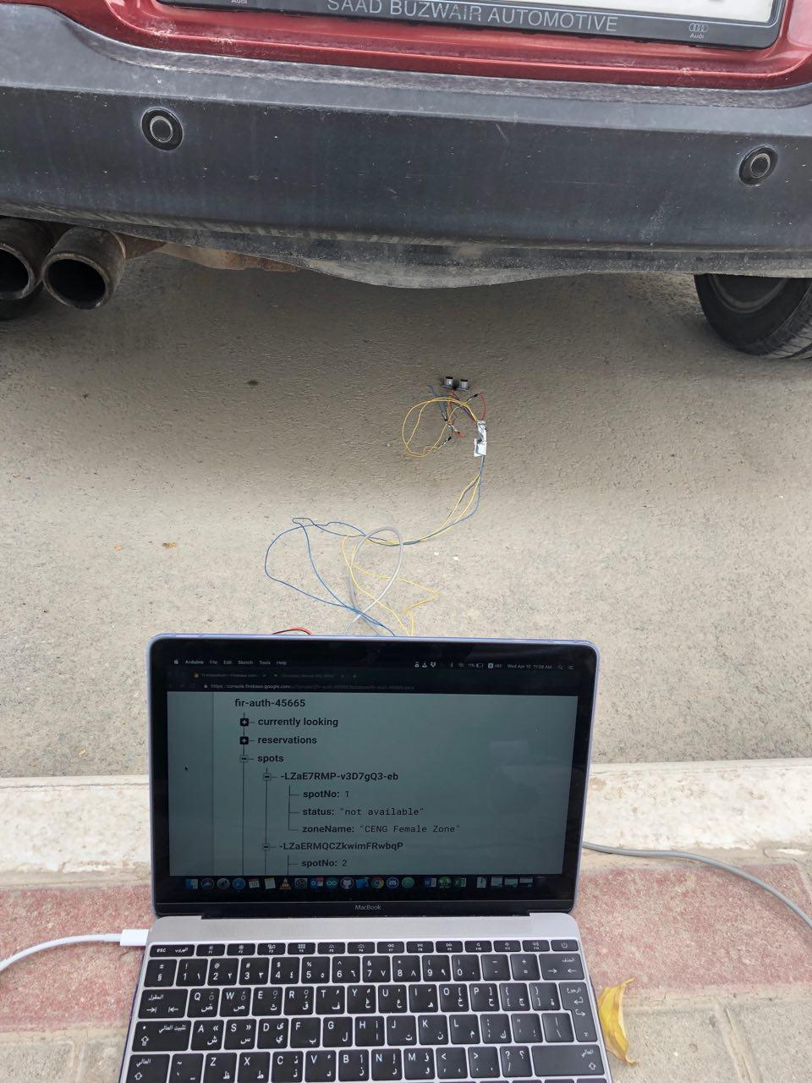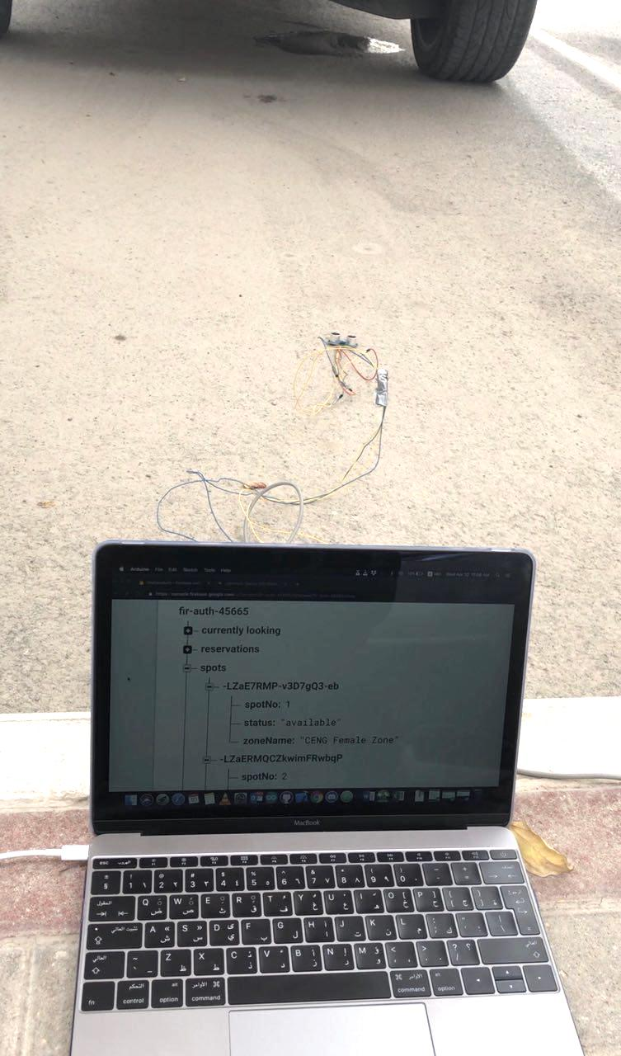

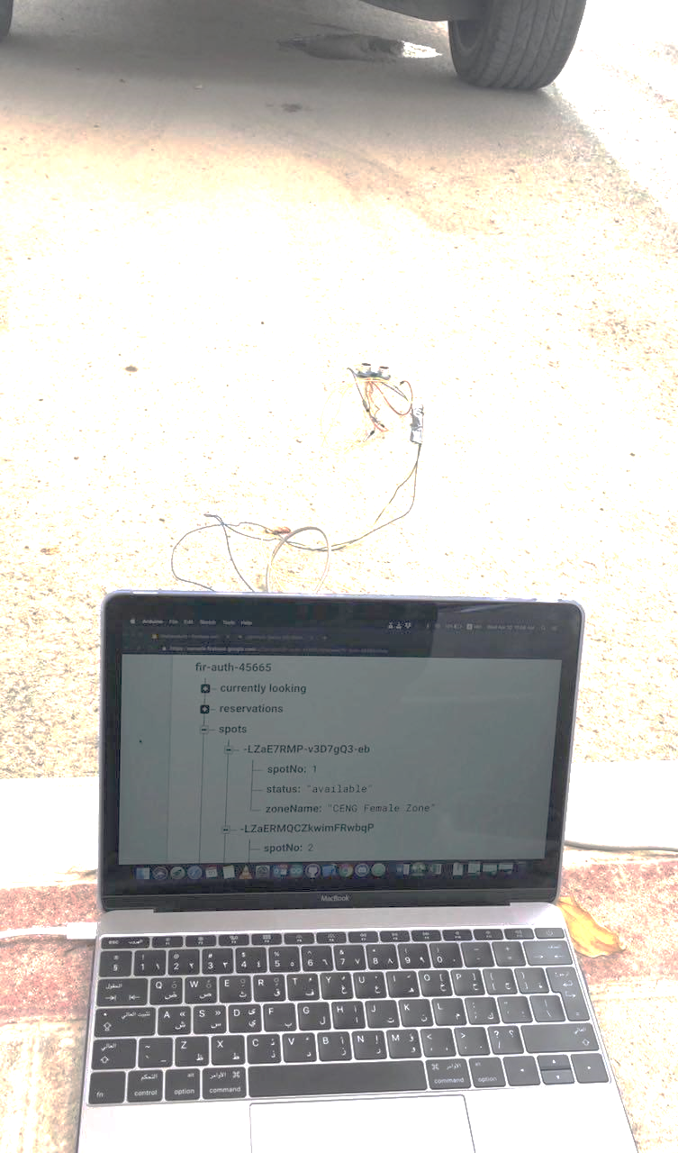

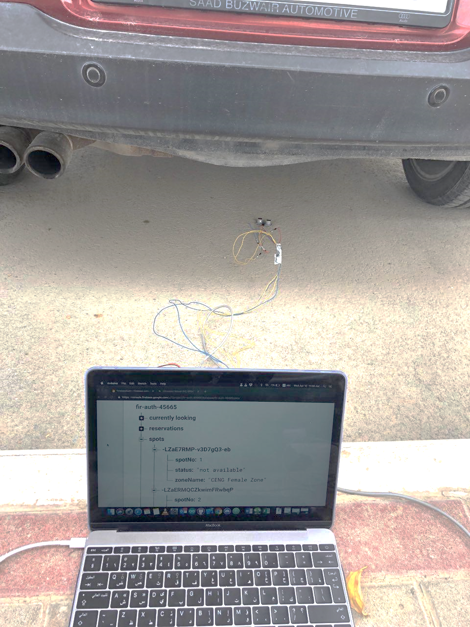

Figure Status "available"

Figure Status "not available"

Furthermore, when the system is implemented in real life, the sensor installation positions must be studied to pick the best position with the environment taken into consideration. Table 6.x shows the different positions a sensor could be placed in real life along with its pros and cons.

Possible installation positions

|  |  |  |  |  |
| --- | --- | --- | --- | --- |
| Position in a parking spot | Distance limit | Where | Pros | Cons |
| Above | Shortest possible car height | Indoors and outdoors | - Sensor protected from rain and dirt.  - Less susceptible to breaking | - Needs a parking shade to place the sensor under it |
| Below | Highest possible car height | Indoors | - Cheapest | - Easily subjected to dirt if outdoors  - Easily breakable (Sensor needs some kind of shield which is costly) |
| In front | Farthest possible distance a car could park | Indoors and outdoors |  | -Cars may bump the sensor (Sensor needs some kind of shield which is costly)  -needs a stand (Costly)  -Most expensive |

For indoor parking lots, the most suitable sensor position is above the parking spot because the sensor will be less susceptible to breaking and the parking spot will always have a ceiling to place the sensor under it. On the other hand, for outdoor parking lots, the best position can either be above or below the parking spot depending on the environment. Placing the sensor above the parking has a huge benefit compared to below the parking spot, as the sensor will be protected from rain and dirt. However, if the parking lot does not have a shade that is already implemented, then placing the sensor above can be expensive compared to placing it below the parking spot. With that said, installing the sensor below a parking spot will require a shield to protect the sensor from being bumped by cars or covered with dirt.

Appendix

1st Operation: Get reservations (Node of Objects)

|  |  |
| --- | --- |
| NodeMCU connection time to Firebase | |
| Trials | **Get Reservation**  **(177 Bytes)** |
| 1 | 0.350258 s |
| 2 | 0.401654 s |
| 3 | 0.330333 s |
| 4 | 0.331711 s |
| Average | **0.353489 s** |

2nd Operation: Update a value

|  |  |  |
| --- | --- | --- |
| NodeMCU connection time to Firebase | |  |
| Trials | **Get a value**  **(15 Bytes)** | **Set a value**  **(15 Bytes)** |
| 1 | 0.306381 s | 0.383343 s |
| 2 | 0.295115 s | 0.390443 s |
| 3 | 0.296623 s | 0.387329 s |
| 4 | 0.306095 s | 0.393172 s |
| Average | **0.301054 s** | **0.388572 s** |

|  |  |  |
| --- | --- | --- |
| *Application connection time to* | | |
| Trials | **Post User**  **(113 Bytes)** | **Get User**  **(113 Bytes)** |
| 1 | 0.011711 s | 0.007428 s |
| 2 | 0.011810 s | 0.007435 s |
| 3 | 0.011822 s | 0.007423 s |
| 4 | 0.011734 s | 0.007430 s |
| Average | **0.011777 s** | **0.007429 s** |

|  |  |  |
| --- | --- | --- |
| *Application connection time to* | | |
| Trials | **Post Currently Looking**  **(52 Bytes)** | **Get Currently Looking**  **(52 Bytes)** |
| 1 | 0.011628 s | 0.007298 s |
| 2 | 0.011623 s | 0.007295 s |
| 3 | 0.011625 s | 0.007294 s |
| 4 | 0.011630 s | 0.007299 s |
| Average | **0.011627 s** | **0.007296 s** |

|  |  |  |
| --- | --- | --- |
| *Application connection time to* | | |
| Trials | **Post Reservation**  **(177 Bytes)** | **Get Reservation**  **(177 Bytes)** |
| 1 | 0.012106 s | 0.007584 s |
| 2 | 0.012110 s | 0.007590 s |
| 3 | 0.012109 s | 0.007588 s |
| 4 | 0.012115 s | 0.007583 s |
| Average | **0.012112 s** | **0.007586 s** |

|  |  |  |
| --- | --- | --- |
| *Application connection time to* | | |
| Trials | **Post Zone**  **(8606 Bytes)** | **Get Zone**  **(8606 Bytes)** |
| 1 | 0.017234 s | 0.008668 s |
| 2 | 0.017236 s | 0.008664 s |
| 3 | 0.017239 s | 0.008663 s |
| 4 | 0.017235 s | 0.008666 s |
| Average | **0.017236 s** | **0.008666 s** |

|  |  |  |
| --- | --- | --- |
| *Application connection time to* | | |
| Trials | **Post Spot**  **(49 Bytes)** | **Get Spot**  **(49 Bytes)** |
| 1 | 0.011525 s | 0.007122 s |
| 2 | 0.011524 s | 0.007121 s |
| 3 | 0.011526 s | 0.007120 s |
| 4 | 0.011528 s | 0.007124 s |
| Average | **0.011526 s** | **0.007123 s** |

|  |  |  |
| --- | --- | --- |
| *Website connection time to* | | |
| Trials | **Post Reservation**  **(177 Bytes)** | **Get Reservation**  **(177 Bytes)** |
| 1 | 0.490 s | 0.411 s |
| 2 | 0.445 s | 0.420 s |
| 3 | 0.480 s | 0.451 s |
| 4 | 0.482 s | 0.423 s |
| 5 | 0.522 s | 0.416 s |
| Average | **0.4838 s** | **0.4242 s** |

|  |  |  |
| --- | --- | --- |
| *Application connection time to* | | |
| Trials | **Post Currently Looking**  **(52 Bytes)** | **Get Currently Looking**  **(52 Bytes)** |
| 1 | 0.383 s | 0.370 s |
| 2 | 0.370 s | 0.386 s |
| 3 | 0.313 s | 0.406 s |
| 4 | 0.410 s | 0.360 s |
| 5 | 0.436 s | 0.323 s |
| Average | **0.3824 s** | **0.3690 s** |

|  |  |  |
| --- | --- | --- |
| *Website connection time to* | | |
| Trials | **Post User**  **(113 Bytes)** | **Get User**  **(113 Bytes)** |
| 1 | 0.489 s | 0.418 s |
| 2 | 0.409 s | 0.373 s |
| 3 | 0.456 s | 0.436 s |
| 4 | 0.488 s | 0.369 s |
| 5 | 0.414 s | 0.428 s |
| Average | **0.4512 s** | **0.4048 s** |

|  |  |  |
| --- | --- | --- |
| *Application connection time to* | | |
| Trials | **Post Zone**  **(8606 Bytes)** | **Get Zone**  **(8606 Bytes)** |
| 1 | 0.662 s | 0.722 s |
| 2 | 0.666 s | 0.716 |
| 3 | 0.656 s | 0.652 |
| 4 | 0.674 s | 0.712 |
| 5 | 0.712 s | 0.698 |
|  | 0.691 s | 0.654 |
| Average | **0. 8122 s** | **0.8303 s** |

|  |  |  |
| --- | --- | --- |
| *Website connection time to* | | |
| Trials | **Post spot**  **(49 Bytes)** | **Get Spot**  **(49 Bytes)** |
| 1 | 0.362 s | 0.349 s |
| 2 | 0.287 s | 0.320 s |
| 3 | 0.342s | 0.324 s |
| 4 | 0.317s | 0.328 s |
| 5 | 0.345 s | 0.328 s |
| Average | **0.3306 s** | **0.3298 s** |